13. **Deferrals**

* Prepaid expenses

Prior to adjustment, assets are overstated and expenses are understated.

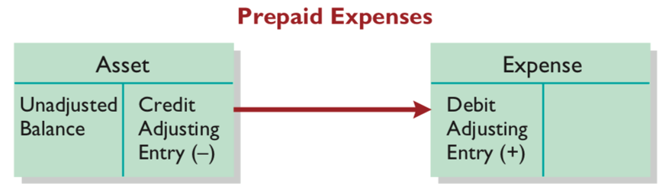

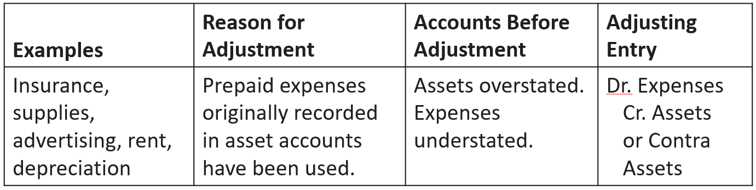

* Unearned revenues

Prior to adjustment, liabilities are overstated and revenues are understated.

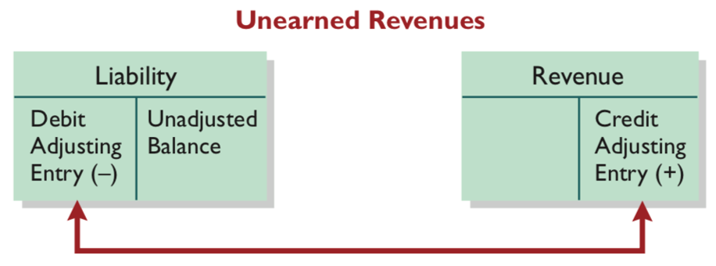

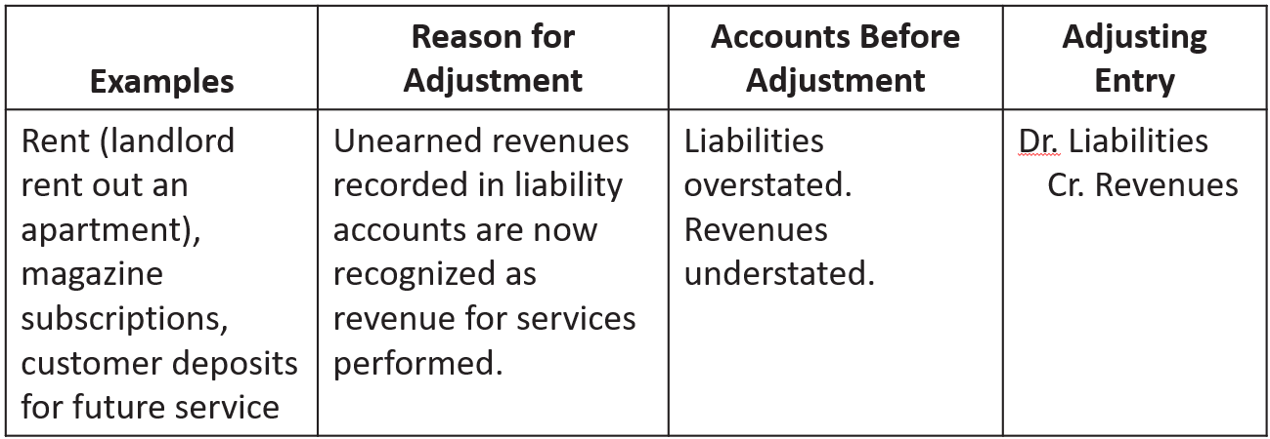

14. **Accruals**

* Accrued revenues

Prior to adjustment, both assets and revenues are understated.

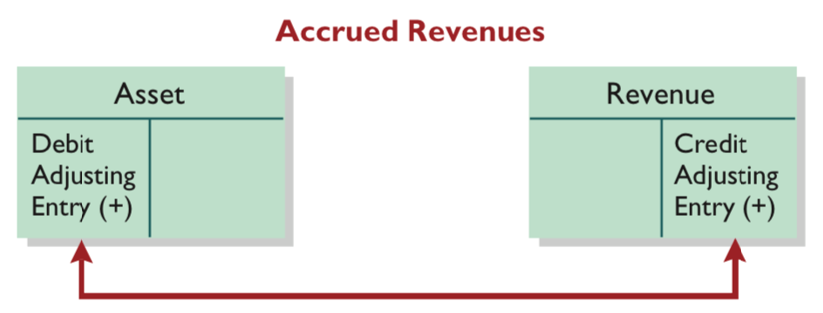

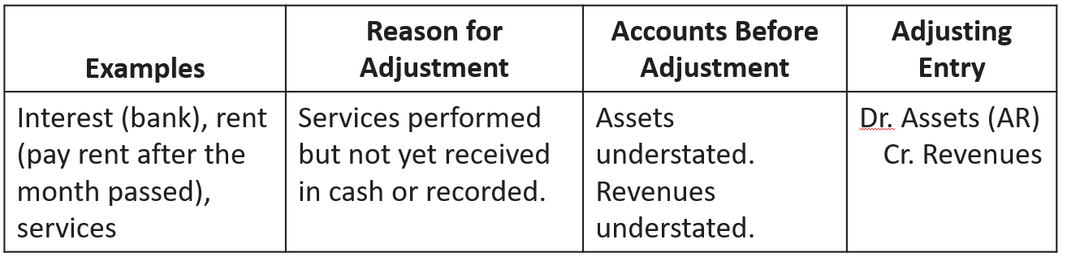

* Accrued expenses

Prior to adjustment, both liabilities and expenses are understated.

